ARC 6228 – Multi-Level PO Approval

This is a modification from ARC 5339 with the addition of feature where Manager level approver can be tied to Vendor and the appropriate limit amount to be able to approve the PO.

For those Manager level approvers where there is no relation to any vendor then the rule for approving the PO is based on the rule in PO Originator Maintenance.

Operation instruction on how to use this ARC:

1. Run ***Purchasing > Administration > Originator Maintenance (6228)***.

There are three levels of approvers: Supervisor, Manager, and Management. Users within Global Shop will be set to the appropriate level of approvers in this screen. The Manager Amount Limit will be used to determine whether the PO approved by Manager level will need to be approved by Management or not. If the PO Amount approved by Manager level is below the Manager Amount Limit then the PO is approved without needing approval from Management level.

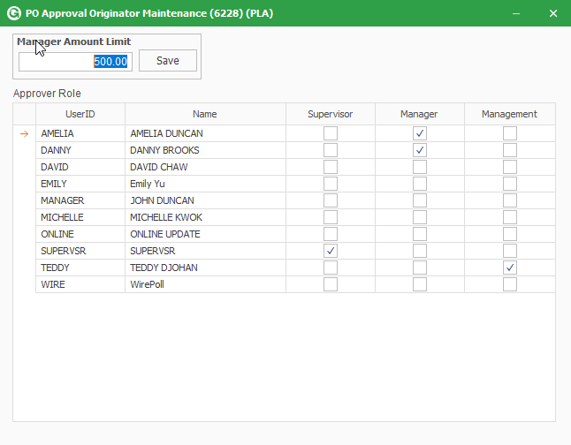

1. Run ***Purchasing > Administration > Manager – Vendor Originator Maintenance (6228).***

Customer will set the Manager level approver and its associated Vendor and Limit Amount in this screen. The users that can be selected in this screen are those users who are set as Manager level approvers in Purchasing > Administration > Originator Maintenance (6228).

From the example below:

AMELIA can only approve PO for Vendor: 2101 with Total Amount up to 8,000.00.

AMELIA can only approve PO for Vendor: BLHW with Total Amount up to 10.00.

For all other vendors, AMELIA can still approve the PO and it will follow the rule set in Originator Maintenance (6228).

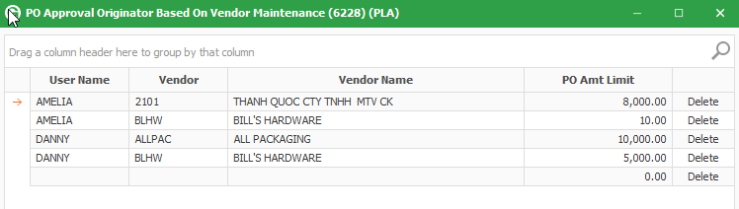

1. Create PO as usual.
2. PO Approval Status can be reviewed from ***Purchasing > View > PO Approval Status (6228)*.**

This screen will show the status of Purchase Order. Approved POs will be shown under Approved tab. POs that are not approved will be shown under Pending tab. Rejected POs are shown under Rejected tab.

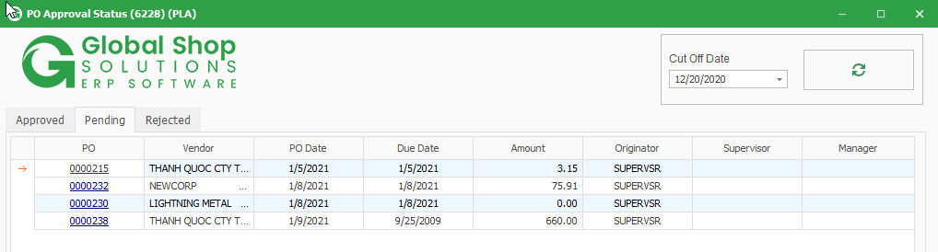

1. The PO will be reviewed and then approved or rejected by Supervisor level approver through ***Purchasing > Transactions > PO Approval List – Supervisor (6228)***.

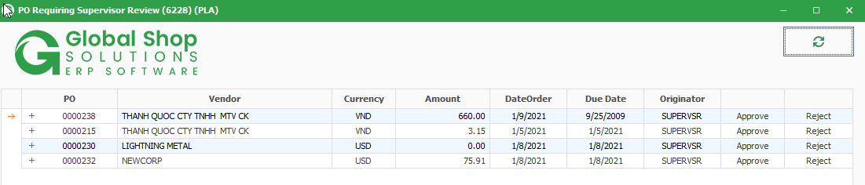

1. Once the PO is approved by Supervisor level approver, it will show up in ***Purchasing > Transactions > PO Approval List – Manager/Management (6228)*** for Manager level approver.

The PO will be reviewed and then approved or rejected by Manager level approver. If the PO Amount approved by Manager level approver is below the Manager Amount Limit set in Originator Maintenance (6228) then the PO will be approved straight away without approval from Management level approver.

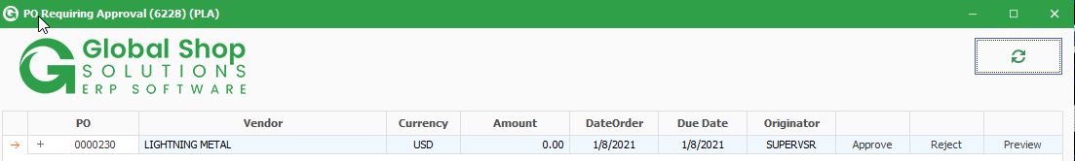

1. Management level approver can approve POs that are already approved by Supervisor level approver without having to wait for approval from Manager level approver through ***Purchasing > Transactions > PO Approval List – Manager/Management (6228)***.

